Supplementary Material
The mechanistic investigation on hydrogen donation performance of bio-acids over bi-functional carbon nanotube catalysts

Jiajun Zhang, Xiaolei Zhang*, Dekui Shen

Contents:
S1. Determination of cut-off energy and K-point spacing for the DFT modelling
S2 Adsorption models of AcOH on metal loaded N_{p}-CNT
S3 Configurations of the transition state for the decomposition of typical groups (methyl, methyl hydrogen, and hydroxyl hydrogen) over Mo/N_{g}-CNT and Mo/N_{p}-CNT respectively

S1 Determination of cut-off energy and K-point spacing for the DFT modelling
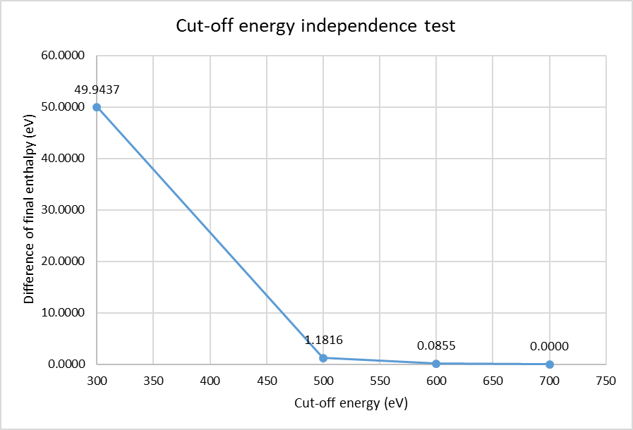
(a)
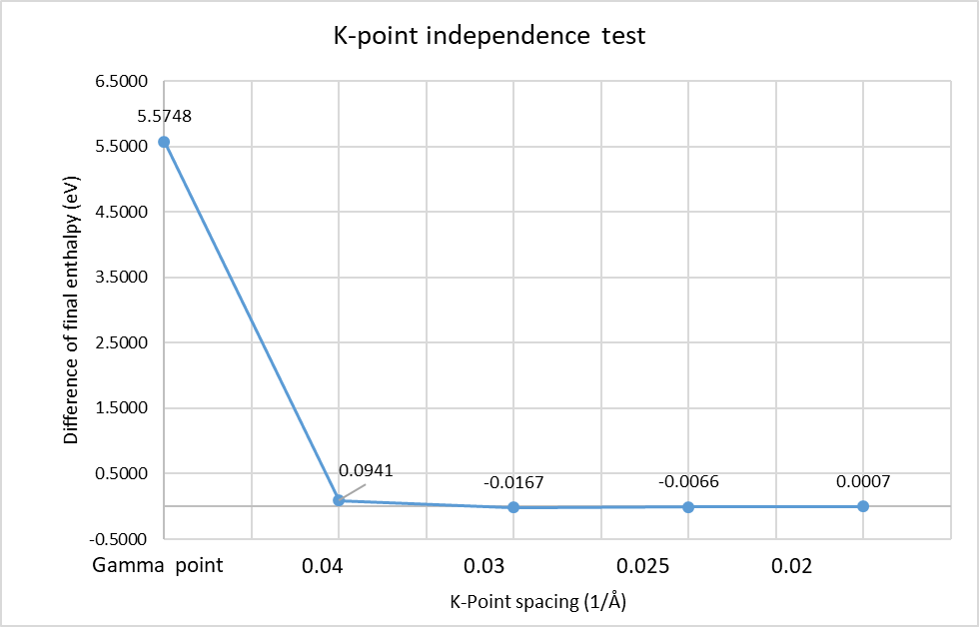
(b)
Note: The tests were carried out based on the model of N_{p}-CNT. The cut-off energy of 700 eV and the k-point spacing of 0.015 Å⁻¹ were considered to predict the highest accuracy in the tests, and other cases were compared to them respectively.

S2 Adsorption models of AcOH on metal loaded N_{p}-CNT
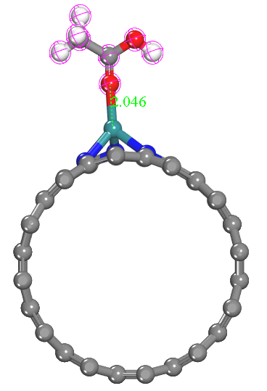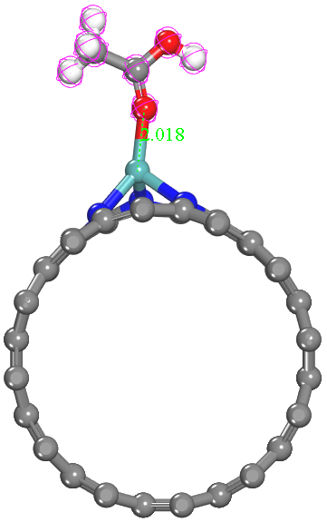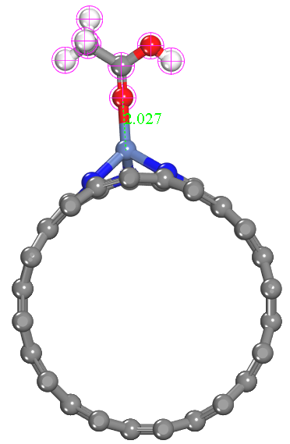
Ru/N_{p}-CNT Mo/N_{p}-CNT Ni/N_{p}-CNT
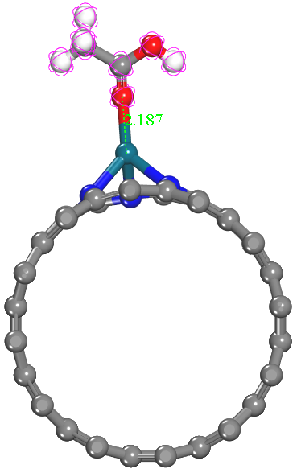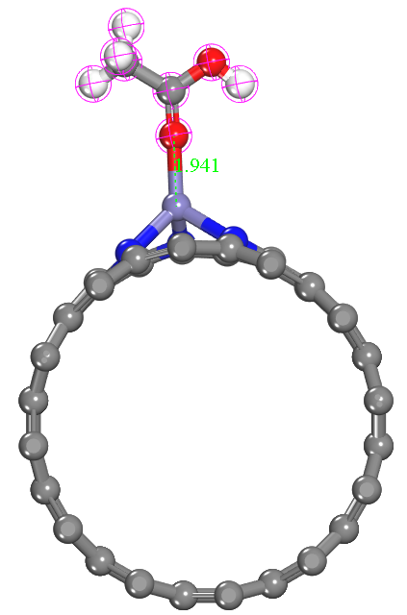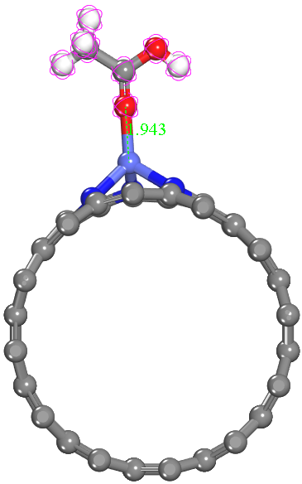
Pd/N_{p}-CNT Fe/N_{p}-CNT Co/N_{p}-CNT
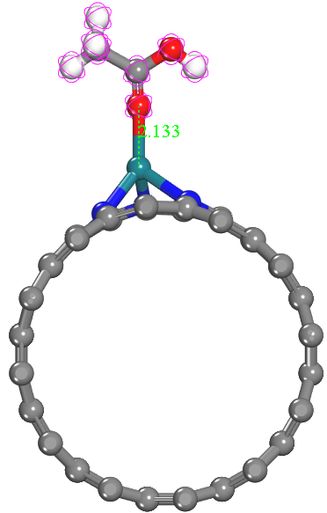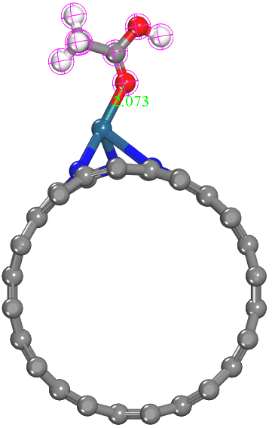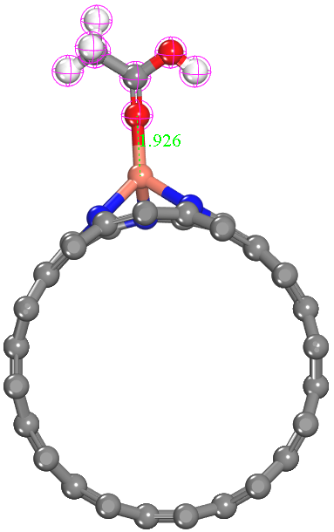
Rh/N_{p}-CNT Pt/N_{p}-CNT Cu/N_{p}-CNT
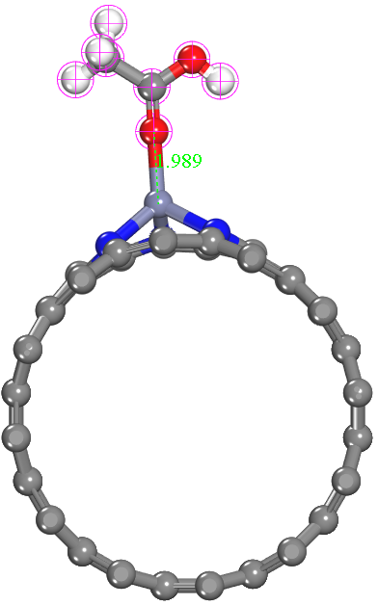
Zn/N_{p}-CNT

S3 Configurations of the transition state for the decomposition of typical groups (methyl, methyl hydrogen, and hydroxyl hydrogen) over Mo/N_{g}-CNT and Mo/N_{p}-CNT respectively
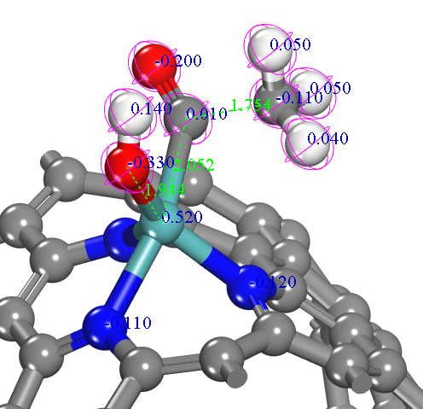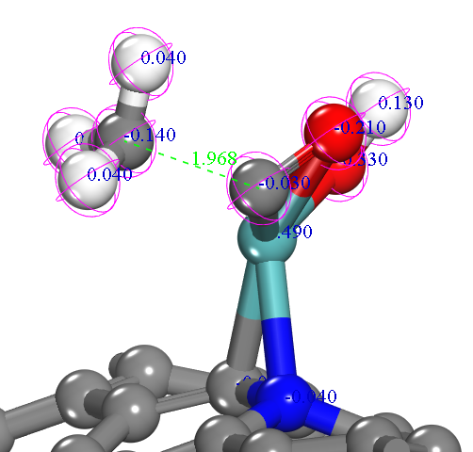
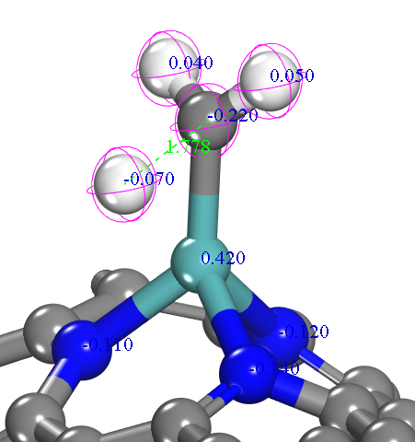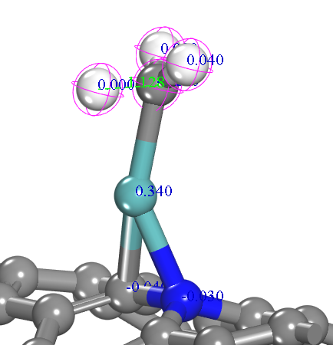

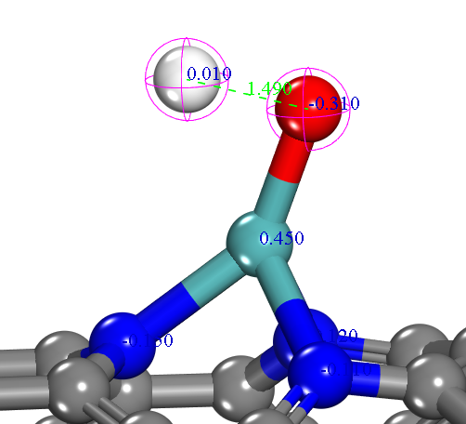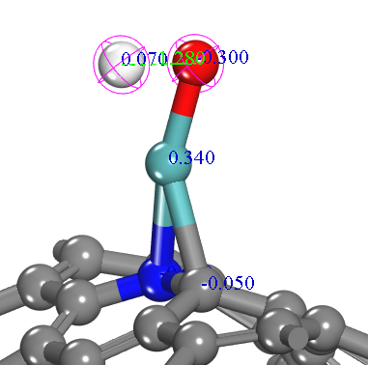

* Corresponding author: X.Z., E-mail address: xiaolei.zhang@strath.ac.uk

